Exhaustive Analysis of Indian Agriculture using Power Bi

(week 1)

**What is Power BI?**

Power BI stands for Business Intelligence. It is a Microsoft-provided tool for analyzing and visualizing raw data, turning it into actionable insights.

**Key Terms:**

*ETL Process:

*Extract: Pull data from sources like Excel, CSV, or text files.

*Transform: Process and clean the data.

*Load: Finalize data for analysis.

**Steps to Use Power BI:**

**1. Download and Install Power BI:**

- Get the latest version from the Microsoft website.

- Install it on your system.

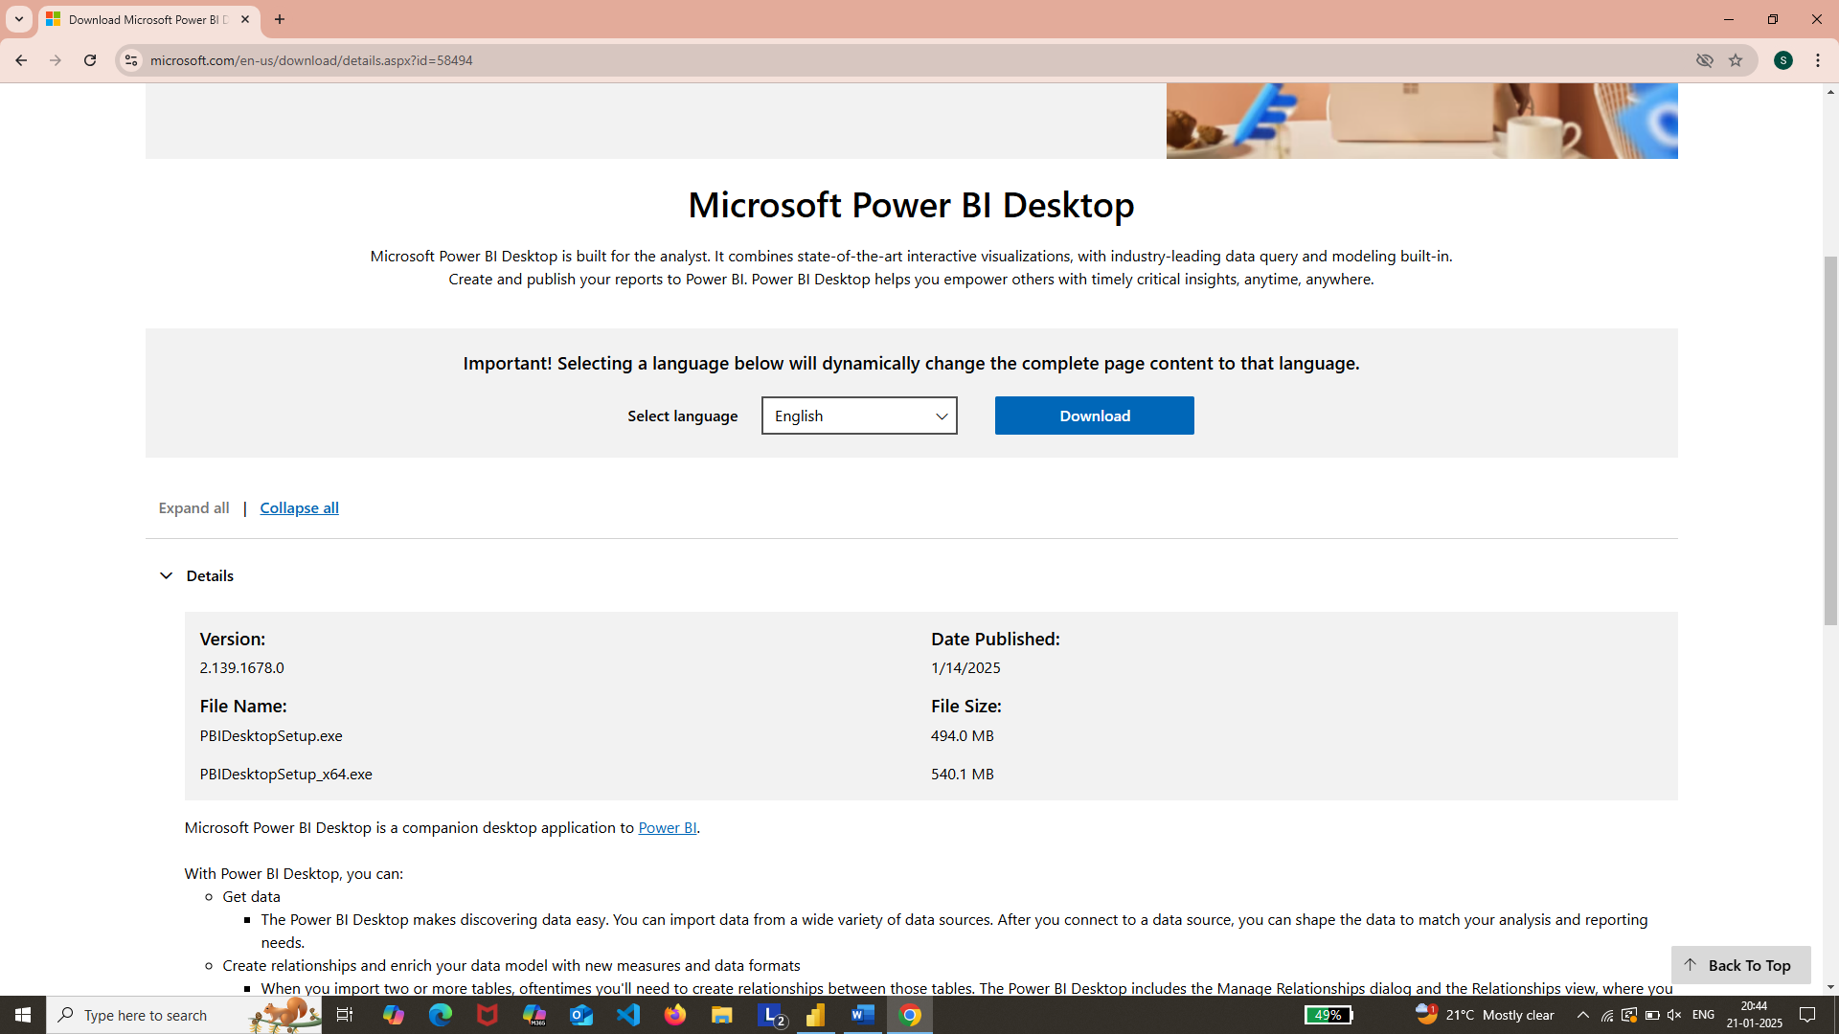

2. **Start Power BI:**

- Open Power BI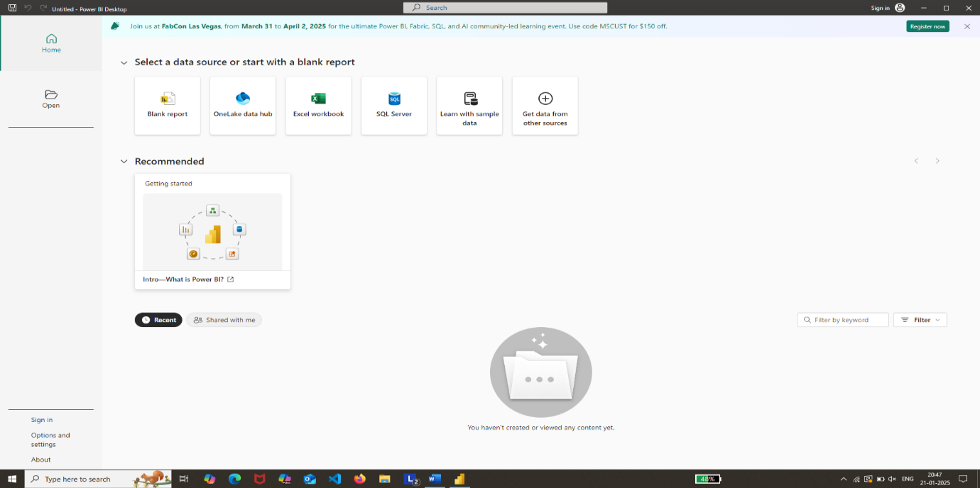

- Choose the **Blank Report** option.

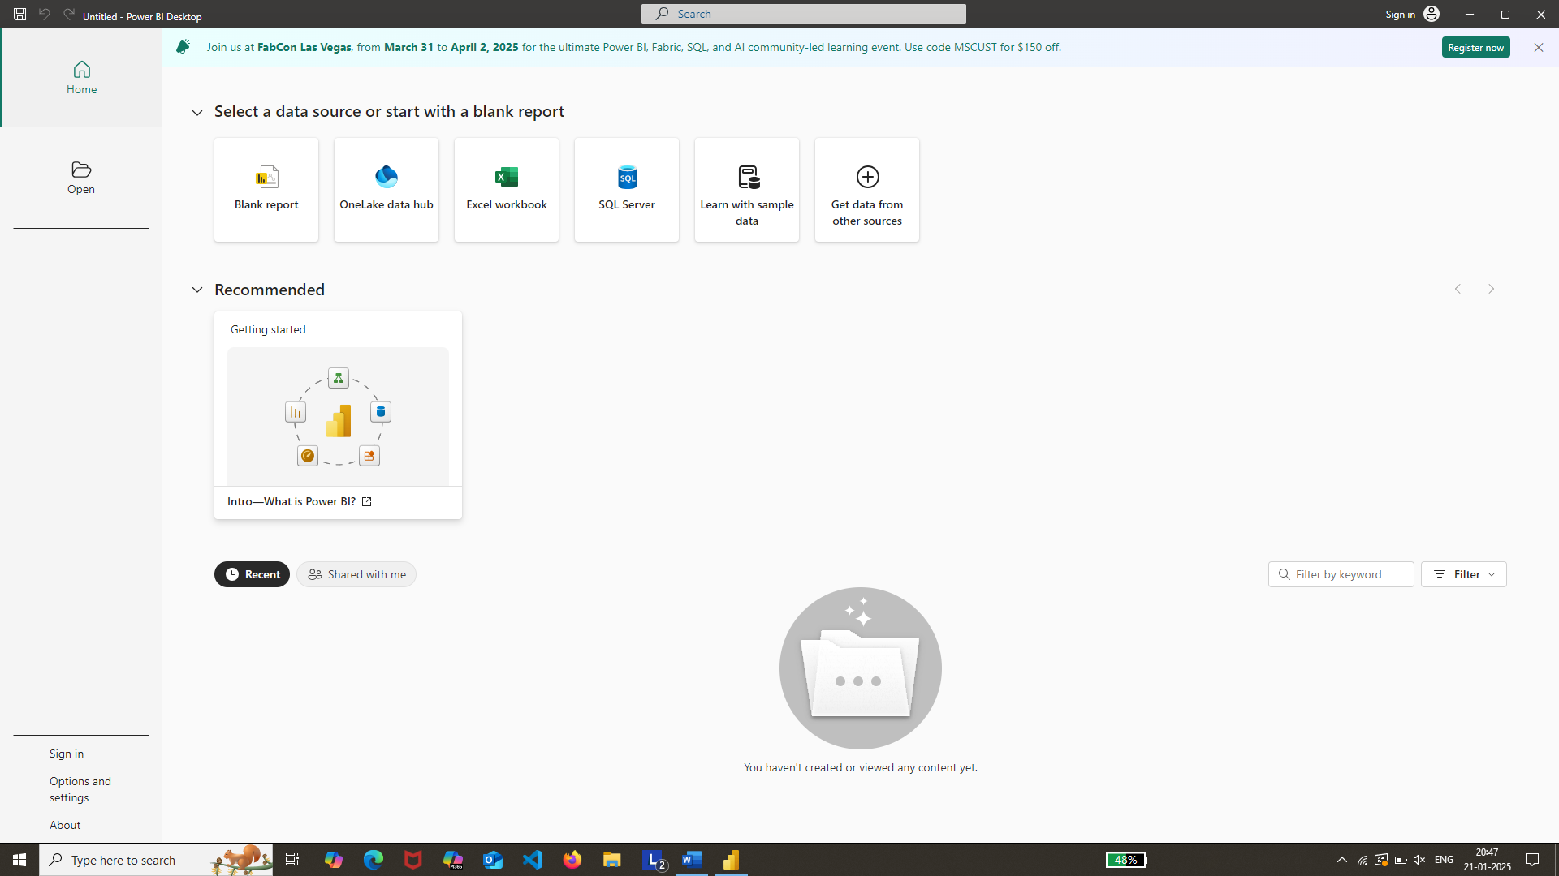

3**. Load Data:**

- Click on Get Data.

- Select \***Text/CSV**\* from the dropdown menu.

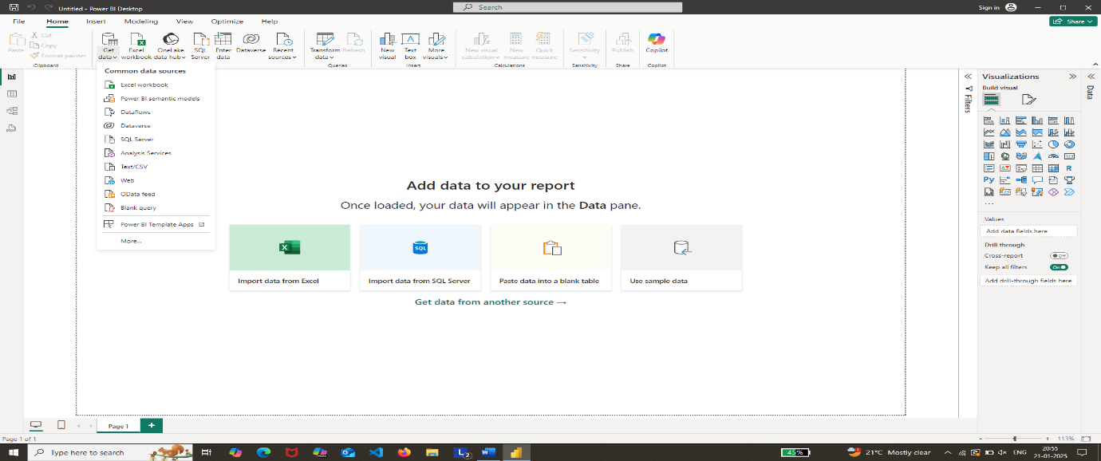

- Upload your dataset.

4. **Prepare Data:**

- Two options appear: Load (for clean data) or Transform Data (for processing).

- Choose Transform Data to clean and process your dataset.

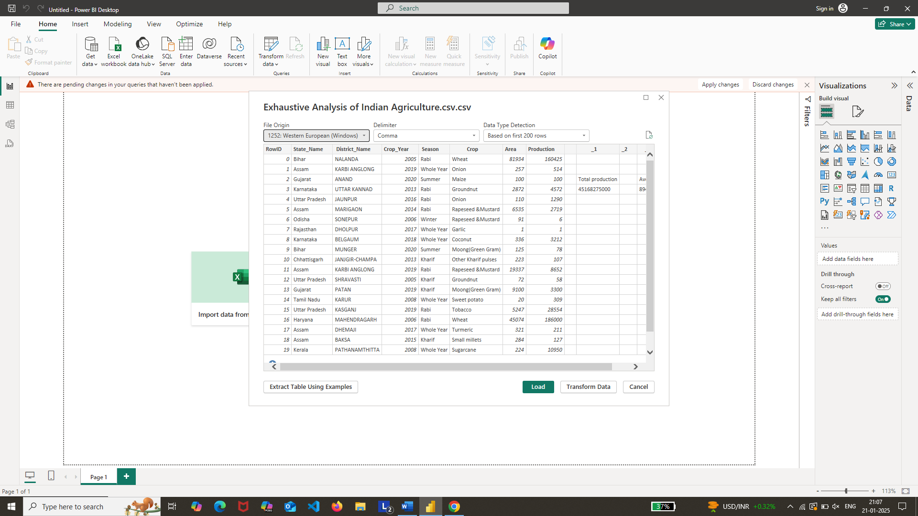

5. **Transform Data in Power Query Editor:**

- Unnecessary columns like "**RowID**" can be removed by right-clicking and selecting *Remove*.

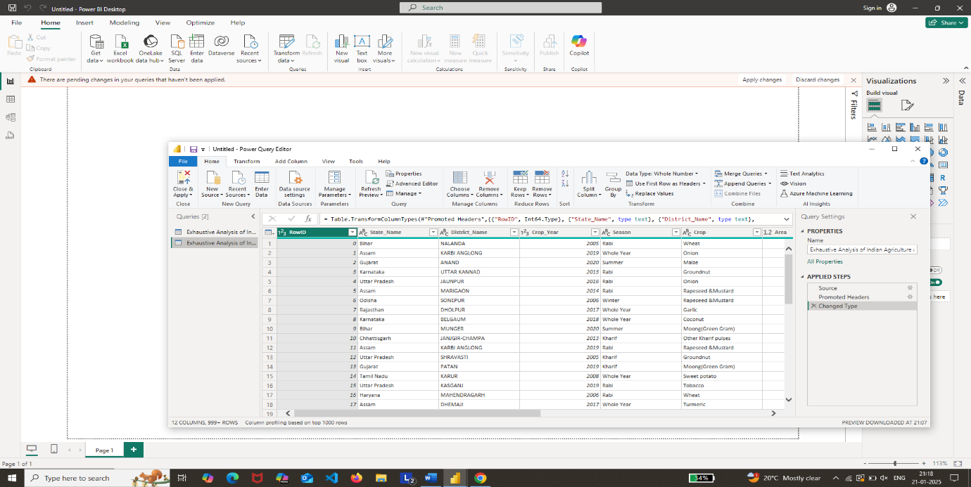

- Delete empty columns similarly.

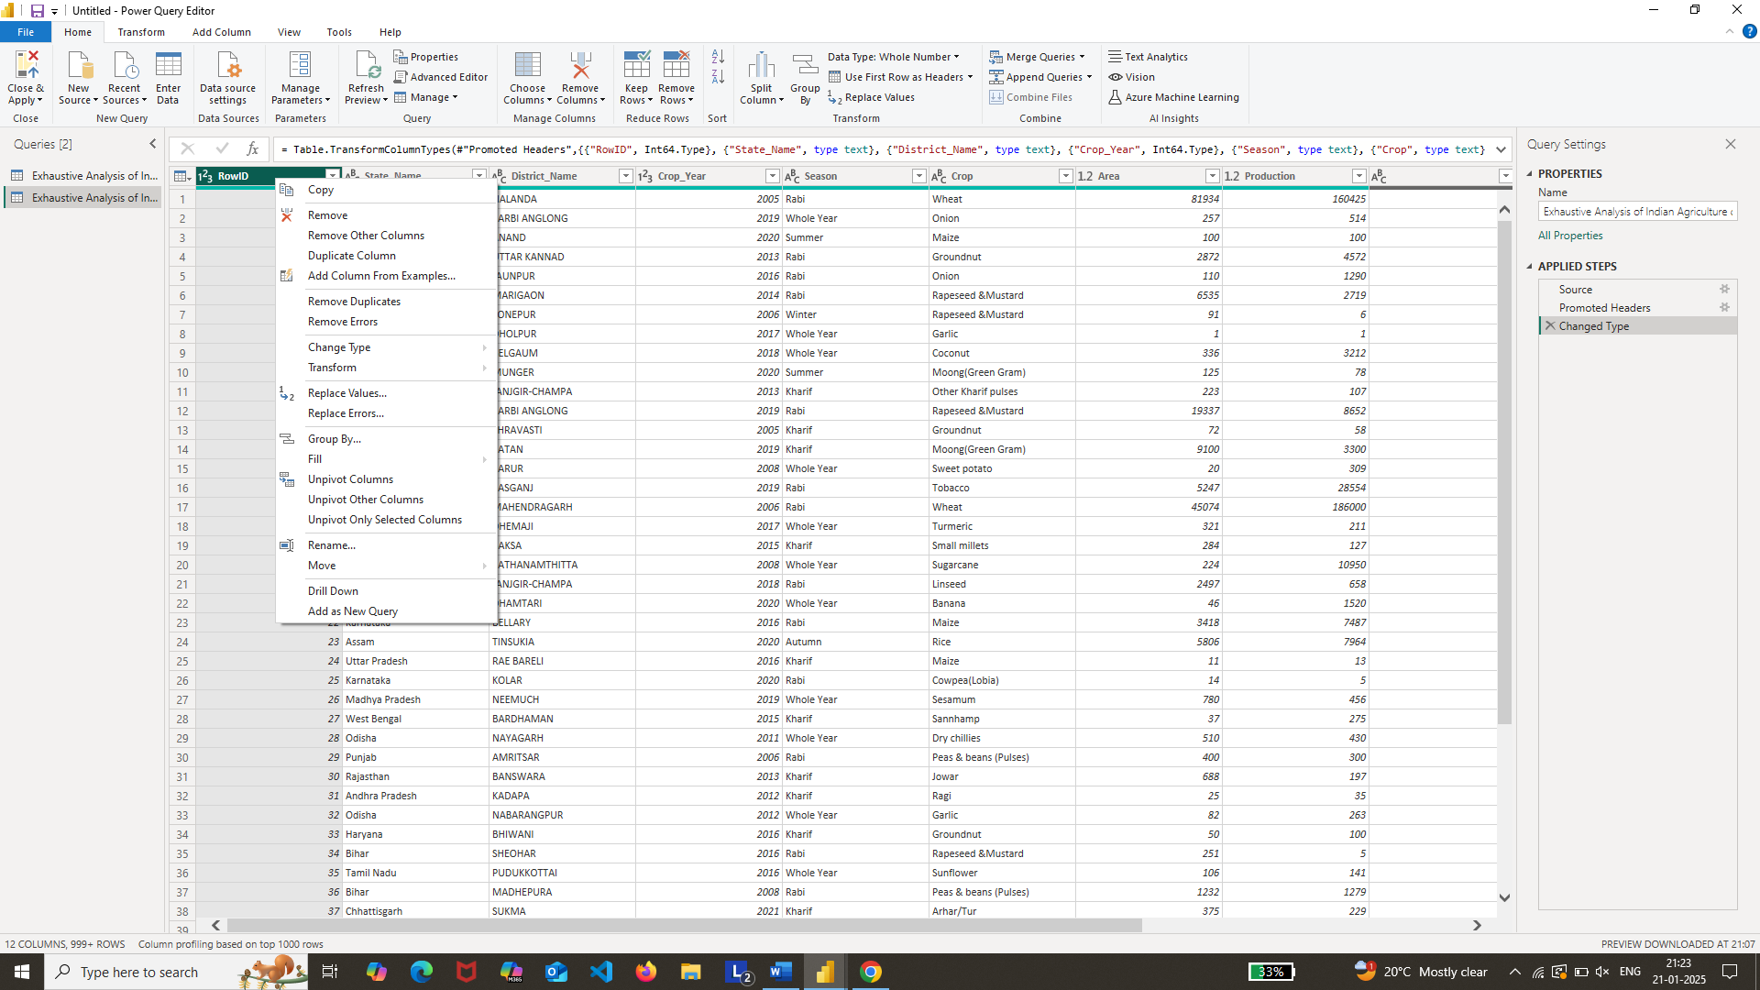

6. **Check Data Quality:**

- Go to the \***View**\* tab and enable *Column Quality*.

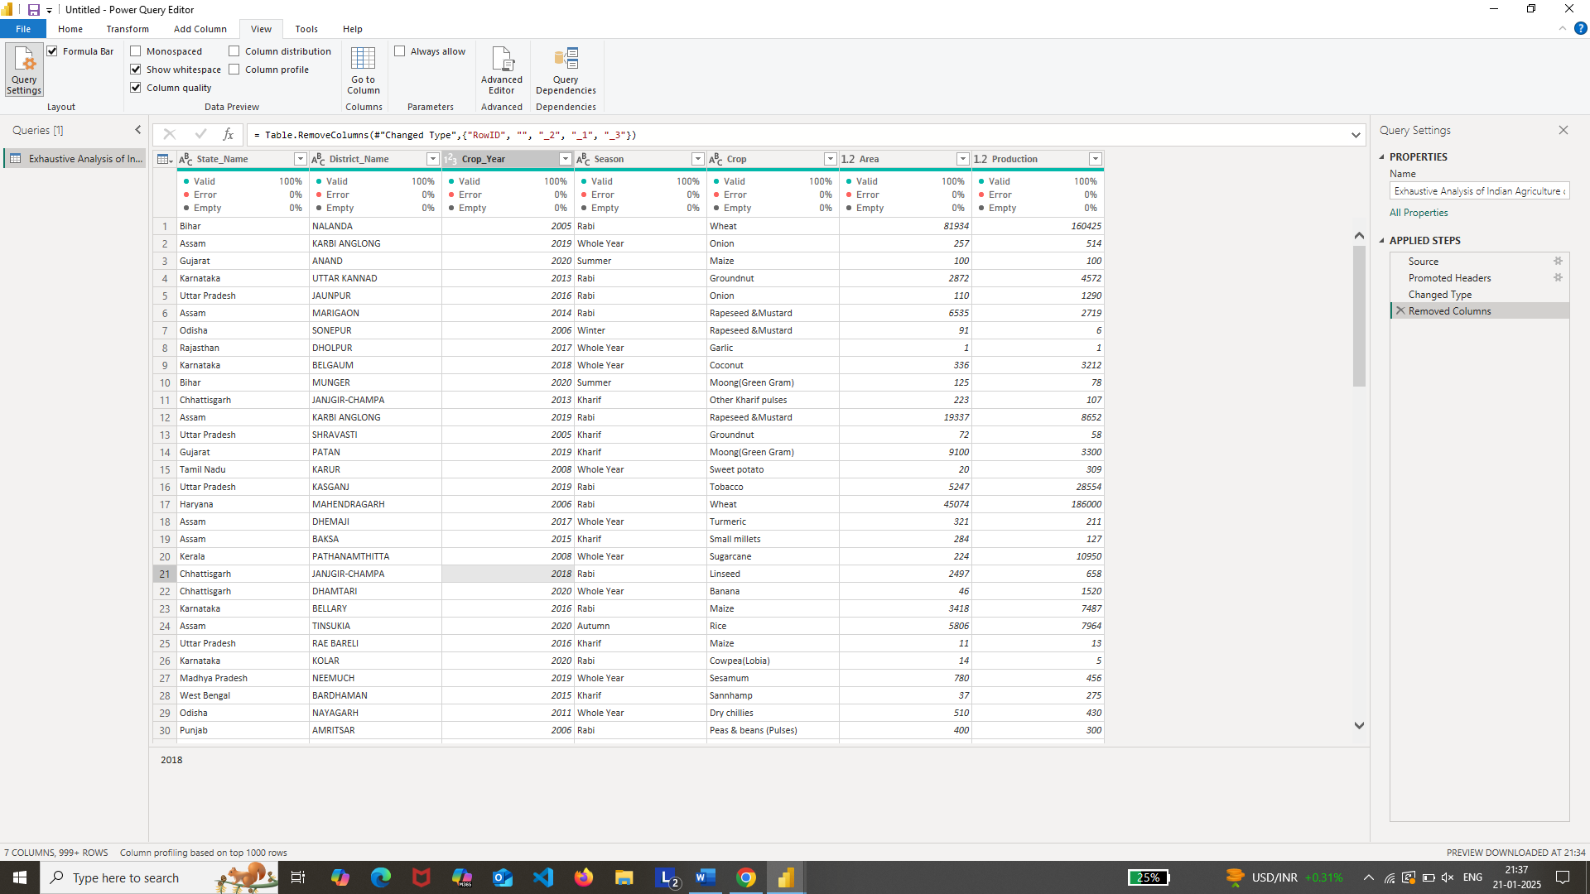

- If the data is valid (e.g., 100%), it is ready for use.

7. **Load Processed Data:**

- Click on \***Close & Apply**\* to load the cleaned dataset.

